SATISH CHANDRA MEMORIAL SCHOOL
CLASS TEST FOR HOTS
CLASS III
Time- 35 min ENVIRONMENTAL SCIENCE Marks-16
Riya notices that a plant near a window bends towards the sunlight. The best reason is
A. The plant wants to move outside
B. The plant needs sunlight for growth
C. The plant is attracted by the window
D. The wind is pushing the plant
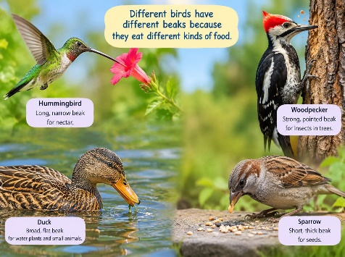
2. A bird has a strong, curved beak. It is most likely adapted to
A. Suck nectar
B. Crack or tear food
C. Drink only water
D. Pick up tiny grains only
3. A family shares household work among its members. This arrangement mainly helps to
A. Make one person do all the work
B. Complete work more easily
C. Stop family members from helping
D. Increase the amount of work
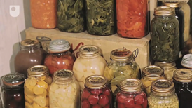
4. A child notices that her grandmother knows many traditional methods of storing food. Such knowledge is valuable because it
A. Is always difficult to understand
B. Can help us use useful practices from the past
C. Makes modern methods unnecessary
D. Can be used only by old people
5. A pond has plants, fish, frogs and insects. If most plants disappear, the pond animals may
A. Get more food
B. Have less food and shelter
C. Become larger immediately
D. Stop needing water
6. A dog becomes excited when it sees its owner but stays alert around a stranger. This difference is mainly related to
A. Its previous experiences
B. The colour of the owner's clothes
C. The time of day
D. The size of the house
7. Two families have the same number of members but different daily routines. The most likely reason is
A. Families always follow identical routines
B. Their work, habits and responsibilities may differ
C. Their members cannot communicate
D. Their houses must have the same size
8. A farmer grows more than one kind of crop in a field. One advantage can be
A. Greater variety of crops
B. No plants need water
C. The soil can never change
D. All crops mature on the same day
9. Some animals are active at night instead of during the day. This may help them
A. Avoid competition or find suitable food
B. Stop eating food
C. Avoid needing shelter
D. Change their body shape
10. A family moves from a cold region to a hot region. They may need to change their
A. Daily clothing and food habits
B. Number of family members
C. Names of family members
D. Need for sleep
11. A hummingbird has a long, narrow beak. This shape is especially useful for
A. Reaching nectar in flowers
B. Breaking hard nuts
C. Catching large fish
D. Digging deep soil
12. A child sees an injured bird near the school. The most responsible action is to
A. Chase it
B. Handle it repeatedly
C. Inform a responsible adult and seek proper help
D. Take it home without permission
13. A community has farmers, teachers, shopkeepers, cleaners and doctors. This shows that
A. Only one type of work is important
B. Different kinds of work help the community function
C. Everyone must do the same work
D. Some workers are unnecessary
14. A plant kept in a dark cupboard for several days becomes weak. This observation suggests that plants
A. Need sunlight for healthy growth
B. Do not need air
C. Grow better without light
D. Need only soil
15. Two families celebrate the same festival in different ways. This can happen because families may have different
A. Traditions and customs
B. Needs for food
C. Number of days in a week
D. Needs for sunlight
16. Many trees are cut down from a forest. The immediate effect on forest animals will be
A. More shelter for all animals
B. Loss of food and shelter
C. More trees for nesting
D. No change at all

